Introduction

3D printing, also known as additive manufacturing (AM), is a manufacturing technique that allows for the manufacture of lighter, stronger parts and systems using layer by layer deposition of the materials using a computer Aided Design(CAD) file.

It has made it easier to manufacture the complex geometry components which are hard to make using the traditional subtraction method[1].

Additive manufacturing is a crucial enabling technology in a variety of industries [2, 3], including aerospace [3, 4], biomedical [4, 5], automotive [6, 7], and turbomachinery [8] Manufacturing and manufacturing aids, such as tooling, jigs, and fixtures, are also relevant areas for AM [8,9].

Materials Used in Additive Manufacturing.

There are several materials that have been used in additive manufacturing including ABS[10],PLA[12],acrylics[11],Epoxies, photopolymers[15] and Polyamides[18] for manufacturing of plastic or advance polymers[14] components and even Metal powders are used in manufacturing of metal components like alloys of Aluminum[20],Ti[21],Gold,Iron[19],Nickel and many others.

With further research more materials are being developed that could be manufactured through 3-D printing [13,16].

DEFECTS IN FDM

While FDM is the cheapest and a good way of 3-D printing many defects can occur while printing that can lead to undesired or different product quality.

Some of the commonly occurring errors are-

* Voids in 3-D printed structure-Voids can happen in several layers that reduces the mechanical strength of the product.[23]
* High temperature of the extrusion nozzle can melt some materials ahead there melting point leading to a high flowing rate that can produce bad layer structures.
* Stringing-This also occurs due to higher extrusion temperatures when it makes extra strings while retraction[24]
* Due to low bed temperature or presence of cool air defects like warping ,warpage[25],and Layer cracking also develops in the structure which reduces the mechanical properties .

Machine Learning

Machine learning is a good solution to optimize the process parameters in AM process.It is used in design,defect detection and much more[26].

Several attempts have been made to monitor the defects during the FDM process.Several Algorithms that have been previously deployed in the field of AM are listed below:

Build-time Prediction: using Neural Network (NN)

Cost Estimation: using Dynamic Clustering

Topology Optimization: using Neural Network (NN), Genetic Algorithms Tolerancing and Thermal Shrinkage Prediction: Bayesian Inference, Convolutional Neural Network (CNN)[22]

Experimental Setup

A CCD camera was set up in front of the FDM machine which captures the image of the printed object continuously(it can capture 42 images per second).However images were not captured continuously as it would create a very huge amount of data. Images were captured at different percentages of the object printing like at 2-5-10-15-20-25-30-35 upto 100 percent.The material used was PLA.

Different objects were printed with 3 different colors(white,red and violet). Those images of the right printed object were kept separate and those with errors were kept separate.

BELOW ARE THE IMAGES OF CORRECT PRINTS WITH 3 DIFFERENT COLORS.

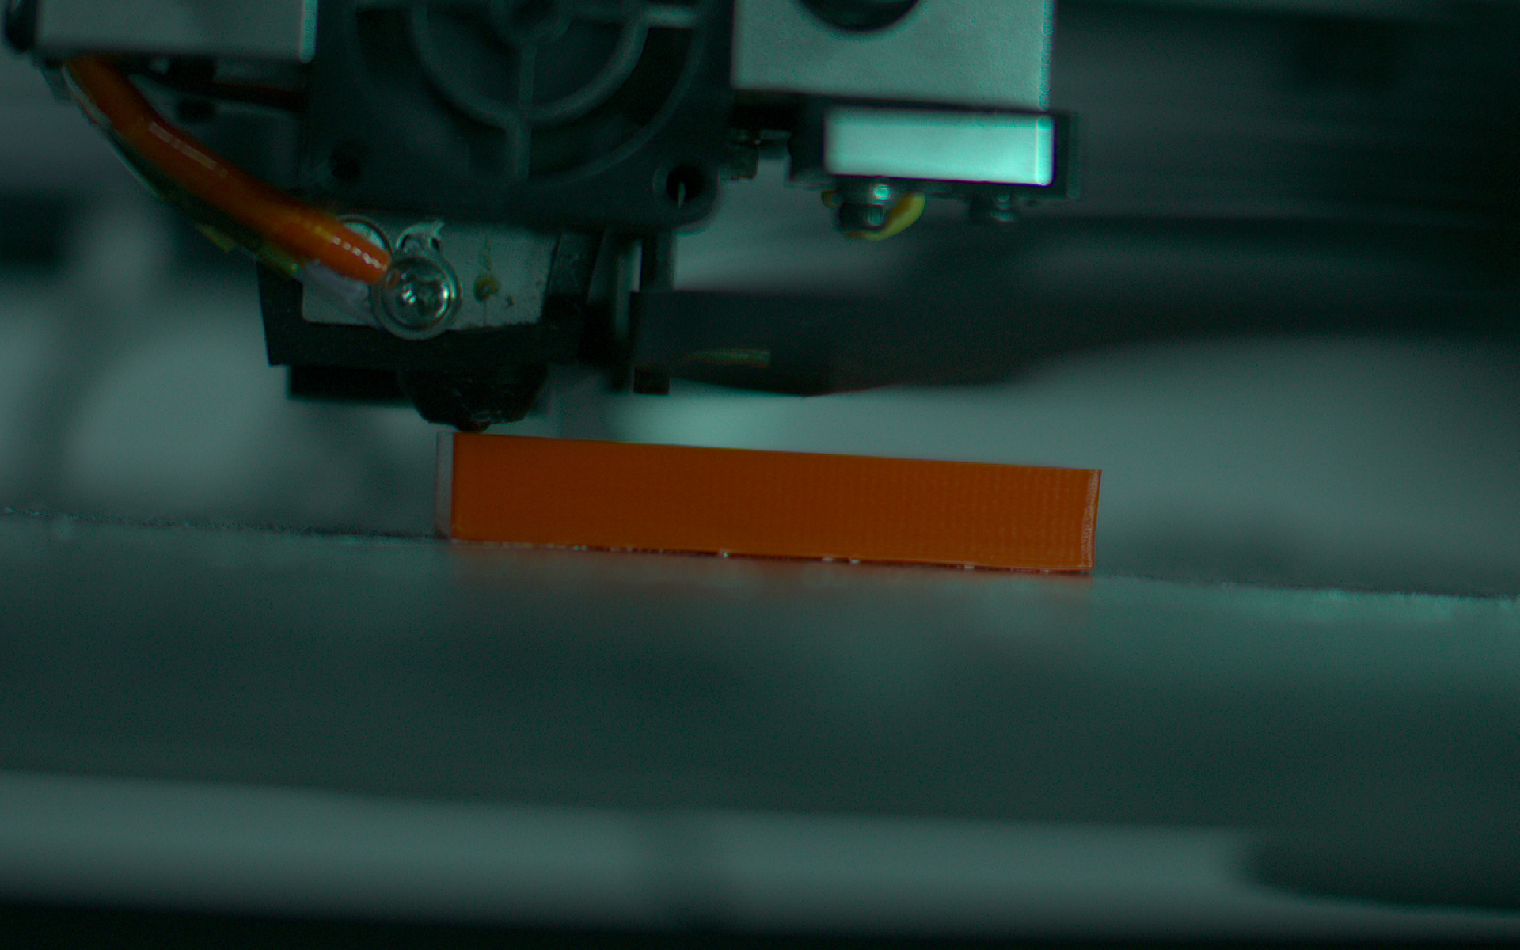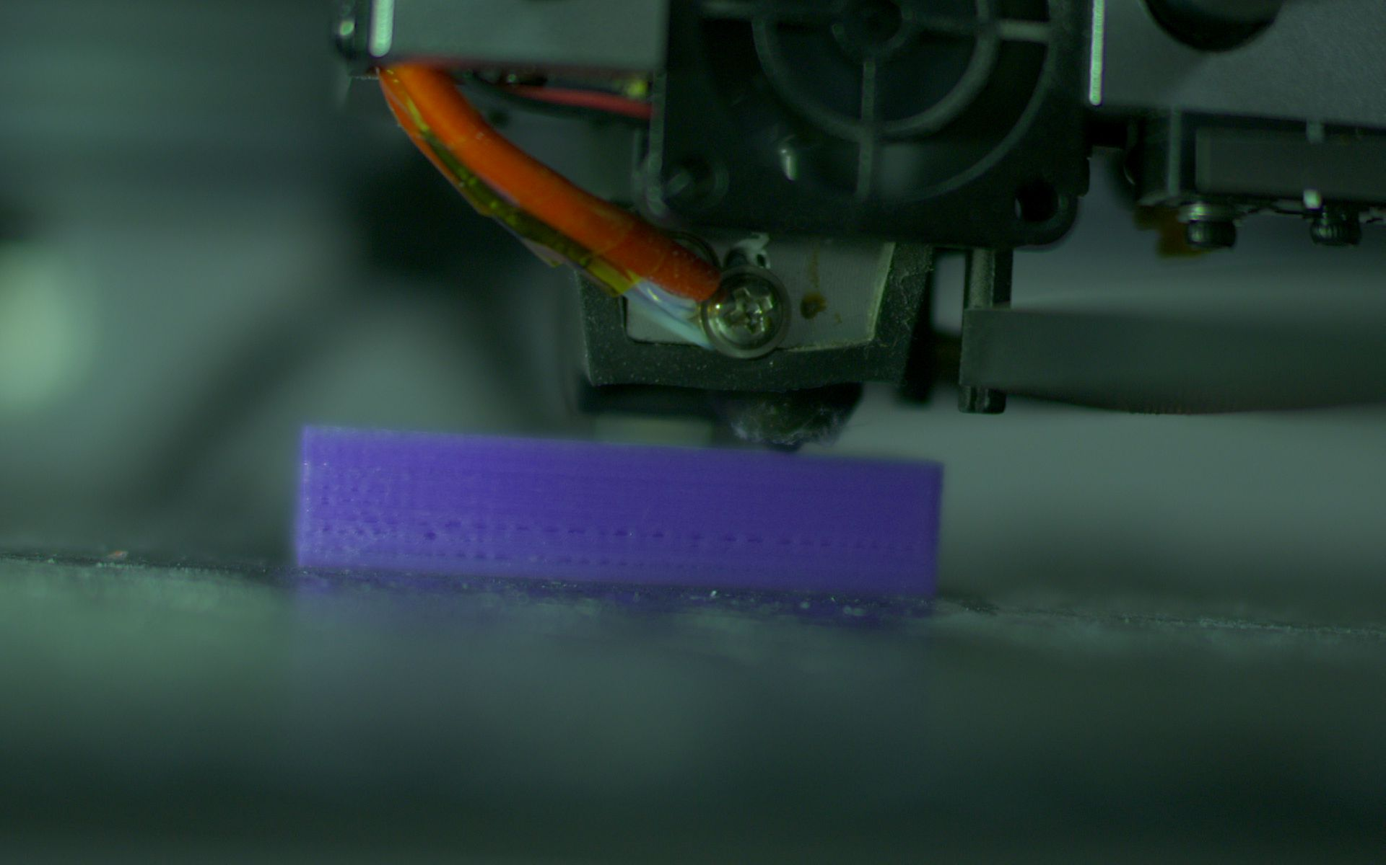

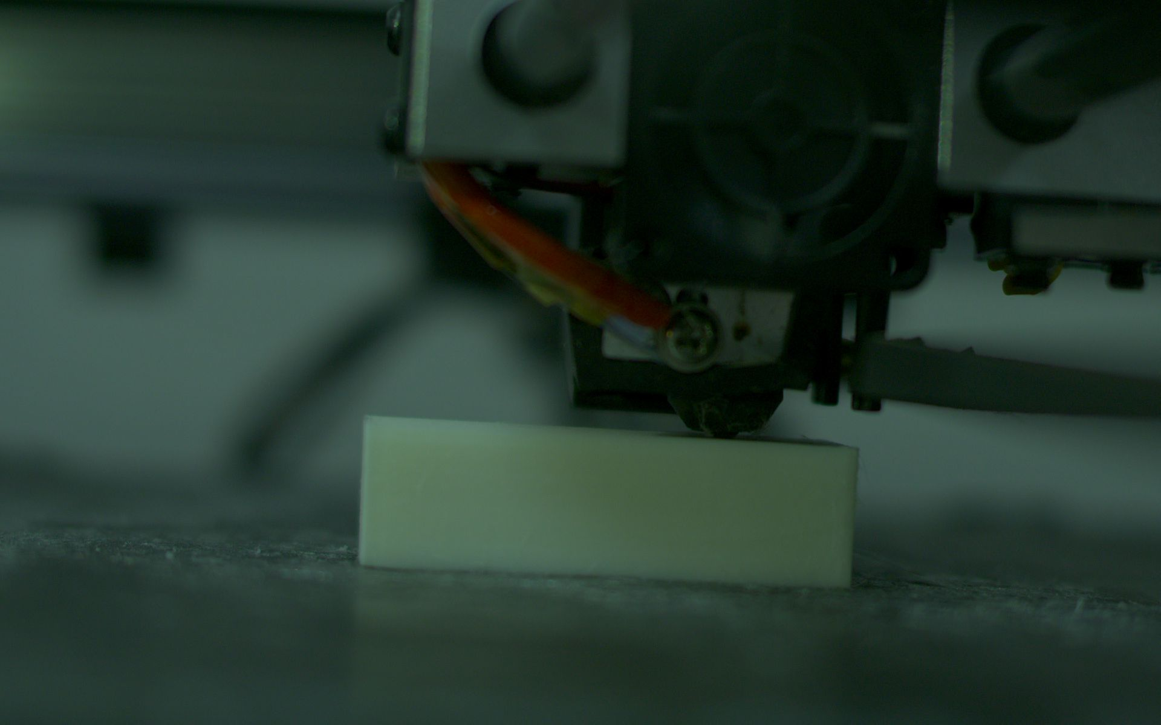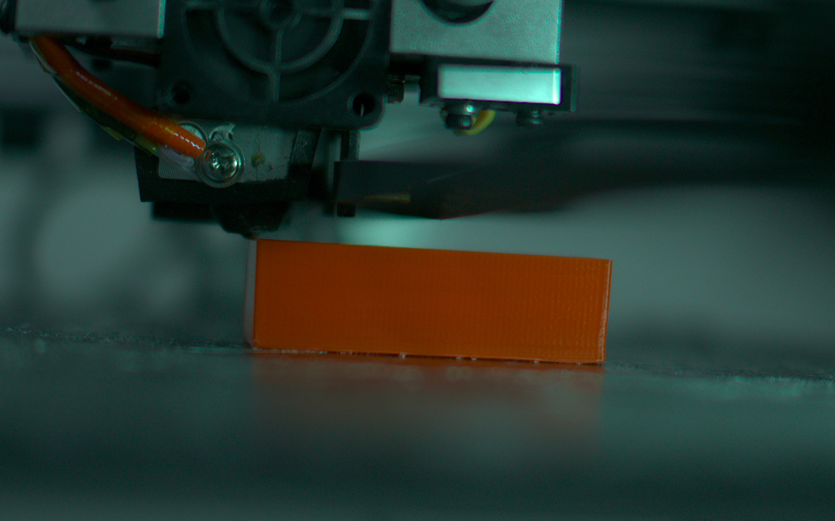

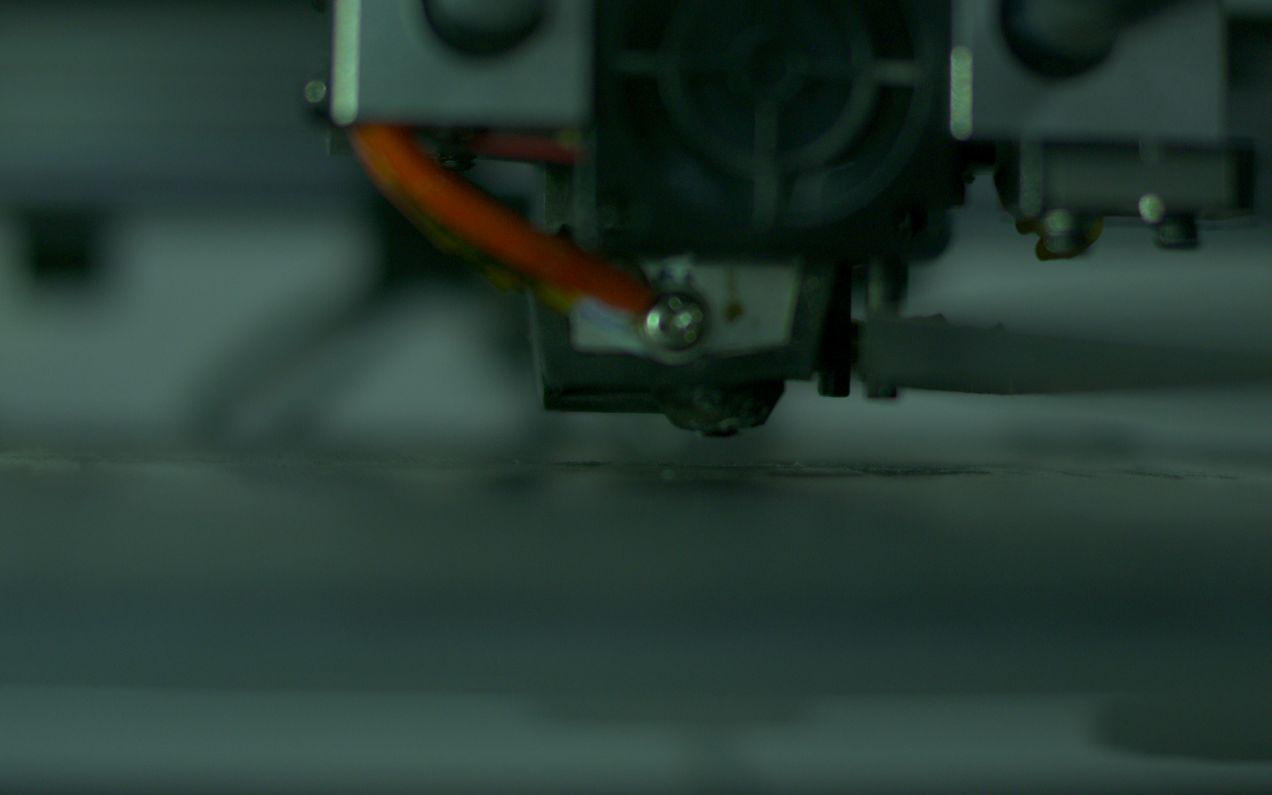

CLOGGED NOZZLE

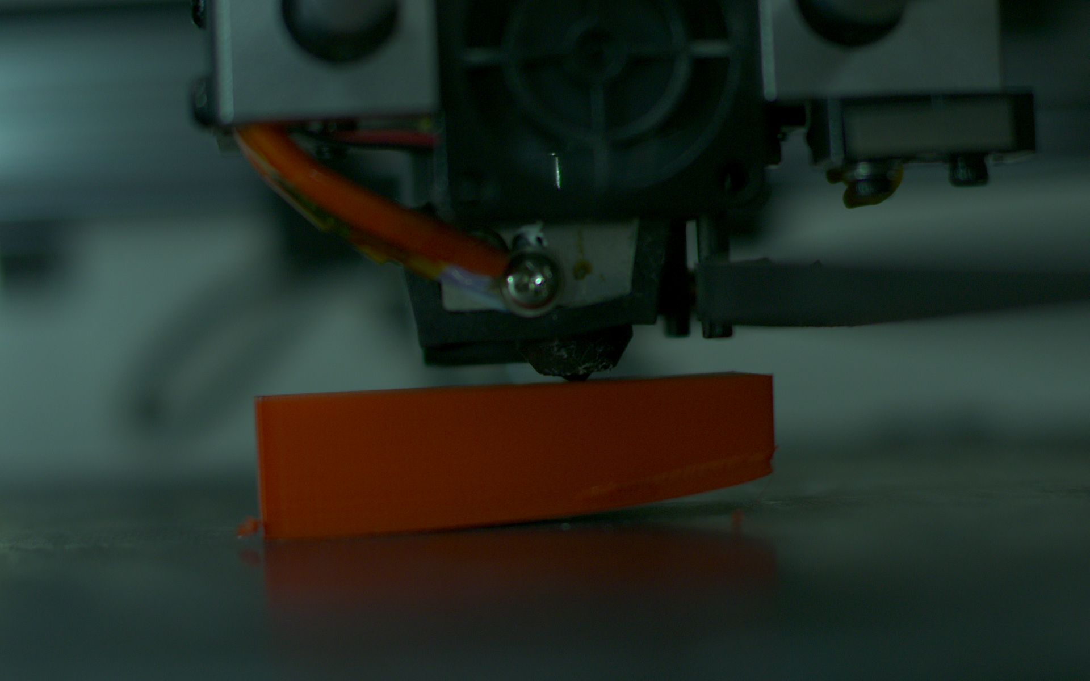

WARPAGE ERROR

Using Machine Learning to make model for error prediction.

In this experiment we have used an open source website EdgeImpulse for making the machine learning model to predict the errors.In this neural networks were used to make the ML model.

For training the model we have used 140 images where the labelling of the images as per the defect is done as

clogging -27 images

perfect -75 images

warpage -38 images

The model is basically a supervised learning method where we uploaded the images that were captured during the FDM process along with the labels(PERFECT,CLOGGING AND WARPAGE)

The Edge Impulse then uses the image and converts them into features and trains a model for us.

For testing the model ,a different set of images were used and our model will predict the labels for them.

The test data that was used consists of-

clogging -8 images

perfect 25 images

warpage -9 images

By changing the learning rates and number of training cycles the model with best F1 score was used to test the accuracy on test data(It tells how accurate will this ML model perform in real time)

The accuracy on test data was found to be 93.33 percent.

Table-Accuracy with different parameters

| Parameters | Number of training cycles | Learning rate | Validation Set | F1 Score | Accuracy  (Test Set) |
| --- | --- | --- | --- | --- | --- |
| 1 | 60 | 0.001 | 20% | 87.5 | 53.85 |
| 2 | 90 | 0.001 | 20% | 96.6 | 82.22 |
| 3 | 200 | 0.003 | 20% | 100 | 84.44 |
| 4 | 300 | 0.005 | 20% | 100 | 93.33 |

It is found that by increasing the training cycles accuracy was also increasing.

The results were very pleasing and the same could be applied during the in situ monitoring of the FDM process.The accuracy of finding the errors is very good through the model that we proposed.

References

[1] Process optimization of complex geometries using feed forward control for laser powder bed fusion additive manufacturing C.L. Druzgalski*, A. Ashby, G. Guss, W.E. King, T.T. Roehling, M.J. Matthews

[2] Wohlers T. Wohlers report 2016. Wohlers Associates Inc; 2016.

[3] Byron Blakey-Milner a,c , Paul Gradl b , Glen Snedden c , Michael Brooks c , Jean Pitot c , Elena Lopez d , Martin Leary e , Filippo Berto f , Anton du Plessis a,g, Metal additive manufacturing in aerospace: A review.

[4] Stansbury JW, Idacavage MJ. 3D printing with polymers: Challenges among expanding options and opportunities. Dent Mater 2016;32:54–64]

[5] Tack P, Victor J, Gemmel P, Annemans L. 3D-printing techniques in a medical setting: a systematic literature review. Biomed Eng Online 2016;15:115.

[6] Vries Cd. Volkswagen Autoeuropa: Maximizing production efficiency with 3D printed tools, jigs, and fixtures. ultimaker.com: Ultimaker B.V.; 2017.

[7] Klocke F, Klink A, Veselovac D, Aspinwall DK, Soo SL, Schmidt M, et al. Turbomachinery component manufacture by application of electrochemical, electrophysical and photonic processes. CIRP Ann 2014;63:703–26.

[8] Rosochowski A, Matuszak A. Rapid tooling: the state of the art. J Mater Process Technol 2000;106:191–8.

[9] Hiemenz J. Production floor trends, justifying additive manufacturing through jigs & fixtures. stratasys.com: Stratasys; 2016.

[10] Polymer additive manufacturing of ABS structure: Influence of printing direction on mechanical properties H. Ramezani Dana⁎ , F. Barbe, L. Delbreilh, M. Ben Azzouna, A. Guillet, T. Breteau→ABS

[11] [Willian de Araújo](https://link.springer.com/article/10.1007/s40430-021-02818-8#auth-Willian-Ara_jo), [Juliana Kloss](https://link.springer.com/article/10.1007/s40430-021-02818-8#auth-Juliana-Kloss) & [Neri Volpato](https://link.springer.com/article/10.1007/s40430-021-02818-8#auth-Neri-Volpato) Evaluating mechanical properties of a photosensitive acrylic resin for additive manufacturing with the addition of organophilic clays →acrylic

[12] [Yuhang Li](https://link.springer.com/article/10.1007/s11665-017-3065-0#auth-Yuhang-Li), [Shiyou Gao](https://link.springer.com/article/10.1007/s11665-017-3065-0#auth-Shiyou-Gao), [Rongmei Dong](https://link.springer.com/article/10.1007/s11665-017-3065-0#auth-Rongmei-Dong), [Xuebing Ding](https://link.springer.com/article/10.1007/s11665-017-3065-0#auth-Xuebing-Ding) & [Xiaoxi Duan](https://link.springer.com/article/10.1007/s11665-017-3065-0#auth-Xiaoxi-Duan)

Additive Manufacturing of PLA and CF/PLA Binding Layer Specimens via Fused Deposition Modeling

[13] Materials for additive manufacturing David Bourell (2)a, *, Jean Pierre Kruth (1)b , Ming Leu (1)c , Gideon Levy (1)d , David Rosen e , Allison M. Beese f , Adam Clare g

[14] 3D printing of polymer matrix composites: A review and prospective-2017

[XinWanga Man Jiangb ZuowanZhoub JihuaGoua DavidHuic](https://www.sciencedirect.com/science/article/pii/S1359836816321230#!)→ Advance polymers

[15] Polymers for 3D Printing and Customized Additive Manufacturing [Samuel Clark Ligon](https://pubs.acs.org/action/doSearch?field1=Contrib&text1=Samuel+Clark++Ligon)* [Robert Liska](https://pubs.acs.org/action/doSearch?field1=Contrib&text1=Robert++Liska) [Jürgen Stampfl](https://pubs.acs.org/action/doSearch?field1=Contrib&text1=J%C3%BCrgen++Stampfl) [Matthias Gur](https://pubs.acs.org/action/doSearch?field1=Contrib&text1=Matthias++Gurr) and [Rolf Mülhaupt](https://pubs.acs.org/action/doSearch?field1=Contrib&text1=Rolf++M%C3%BClhaupt)→photopolymers-2017

[16] Additive manufacturing (3D printing): A review of materials, methods,applications and challenges

Twan D ngo, Aleriza Kashani, Gabriele Imbalzano, Kate T.Q.Nguyen,David Hui–2018

[17]Additive manufacturing of CNTs/PLA composites and the correlation between microstructure and functional properties -2021

[XingZhou](https://www.sciencedirect.com/author/55622049800/xing-zhou) ,[JingruiDeng](https://www.sciencedirect.com/science/article/pii/S100503022030503X#!), [ChangqingFang](https://www.sciencedirect.com/author/56079880000/changqing-fang), [WanqingLei, YonghuaSong, ZisenZhang, ZhigangHuang , YanLi](https://www.sciencedirect.com/science/article/pii/S100503022030503X#!)

[18] Tuomas Puttonen, Mika Salmi, Jouni Partanen,

Mechanical properties and fracture characterization of additive manufacturing polyamide 12 after accelerated weathering-2021

[19]-Tailoring grain sizes of the biodegradable iron-based alloys by pre-additive manufacturing microalloying

* [Chih-Chieh Huang](https://www.nature.com/articles/s41598-021-89022-9#auth-Chih_Chieh-Huang),
* [Tu-Ngoc Lam](https://www.nature.com/articles/s41598-021-89022-9#auth-Tu_Ngoc-Lam),
* [Lia Amalia](https://www.nature.com/articles/s41598-021-89022-9#auth-Lia-Amalia),
* [Kuan-Hung Chen](https://www.nature.com/articles/s41598-021-89022-9#auth-Kuan_Hung-Chen),
* [Kuo-Yi Yang](https://www.nature.com/articles/s41598-021-89022-9#auth-Kuo_Yi-Yang),
* [M. Rifai Muslih](https://www.nature.com/articles/s41598-021-89022-9#auth-M__Rifai-Muslih),
* [Sudhanshu Shekhar Singh](https://www.nature.com/articles/s41598-021-89022-9#auth-Sudhanshu_Shekhar-Singh),
* [Pei-I. Tsai](https://www.nature.com/articles/s41598-021-89022-9#auth-Pei_I_-Tsai),
* [Yuan-Tzu Lee](https://www.nature.com/articles/s41598-021-89022-9#auth-Yuan_Tzu-Lee),
* [Jayant Jain](https://www.nature.com/articles/s41598-021-89022-9#auth-Jayant-Jain),
* [Soo Yeol Lee](https://www.nature.com/articles/s41598-021-89022-9#auth-Soo_Yeol-Lee),
* [Hong-Jen Lai](https://www.nature.com/articles/s41598-021-89022-9#auth-Hong_Jen-Lai),
* [Wei-Chin Huang](https://www.nature.com/articles/s41598-021-89022-9#auth-Wei_Chin-Huang),
* [San-Yuan Chen](https://www.nature.com/articles/s41598-021-89022-9#auth-San_Yuan-Chen) &
* [E-Wen Huang](https://www.nature.com/articles/s41598-021-89022-9#auth-E_Wen-Huang) -2021

[20]- Towards high-temperature applications of aluminium alloys enabled by additive manufacturing

[Richard A. Michi](https://www.tandfonline.com/author/Michi%2C+Richard+A),[Alex Plotkowski](https://www.tandfonline.com/author/Plotkowski%2C+Alex),[Amit Shyam](https://www.tandfonline.com/author/Shyam%2C+Amit),[Ryan R. Dehoff](https://www.tandfonline.com/author/Dehoff%2C+Ryan+R) &[Sudarsanam Suresh Babu](https://www.tandfonline.com/author/Babu%2C+Sudarsanam+Suresh)-2021

[21]- A Review on Additive Manufacturing of Titanium Alloys for Aerospace Applications: Directed Energy Deposition and Beyond Ti-6Al-4V [Zhiying Liu](https://link.springer.com/article/10.1007/s11837-021-04670-6#auth-Zhiying-Liu), [Bei He](https://link.springer.com/article/10.1007/s11837-021-04670-6#auth-Bei-He), [Tianyi Lyu](https://link.springer.com/article/10.1007/s11837-021-04670-6#auth-Tianyi-Lyu) & [Yu Zou](https://link.springer.com/article/10.1007/s11837-021-04670-6#auth-Yu-Zou)

2021

[22]-Mohammad Farhan Khan, Aftaab Alam, Mohammad Ateeb Siddiqui, Mohammad Saad Alam, Yasser Rafat, Nehal Salik, Ibrahim Al-Saidan,

Real-time defect detection in 3D printing using machine learning,-2020

[23]-Qinghao He, Hongjian Wang, Kunkun Fu, Lin Ye,

3D printed continuous CF/PA6 composites: Effect of microscopic voids on mechanical performance,

Composites Science and Technology,-2020

[24]-Minimizing Stringing Issues In FDM Printing [Md. Sabit Shahriar Haque](https://www.researchgate.net/profile/Md-Sabit-Shahriar-Haque-2)(2020)

[25]-Effects of auxiliary heat on warpage and mechanical properties in carbon fiber/ABS composite manufactured by fused deposition modeling Ning Yu a , Xiaoyong Sun a , Zhi Wang b , Daijun Zhang a,b , Jing Li a,c, -2020

[26]-Machine Learning in Additive Manufacturing: A Review(2020)

* [Lingbin Meng](https://link.springer.com/article/10.1007/s11837-020-04155-y#auth-Lingbin-Meng),
* [Brandon McWilliams](https://link.springer.com/article/10.1007/s11837-020-04155-y#auth-Brandon-McWilliams),
* [William Jarosinski](https://link.springer.com/article/10.1007/s11837-020-04155-y#auth-William-Jarosinski),
* [Hye-Yeong Park](https://link.springer.com/article/10.1007/s11837-020-04155-y#auth-Hye_Yeong-Park),
* [Yeon-Gil Jung](https://link.springer.com/article/10.1007/s11837-020-04155-y#auth-Yeon_Gil-Jung),
* [Jehyun Lee](https://link.springer.com/article/10.1007/s11837-020-04155-y#auth-Jehyun-Lee) &
* [Jing Zhang](https://link.springer.com/article/10.1007/s11837-020-04155-y#auth-Jing-Zhang)